USER MANUAL
A-1100G

VERSION A (2017/01/20)

TABLE OF CONTENTS

Descriptions& Specifications 1
Warranty and Warnings 2
Assembly Notes 3
Instruction of Use 9
Care and Maintenance 10
Operation Manual of Console 12
Training Instructions 17
Descriptions & specifications

Hint of how to dispose
- Do not dispose of electrical appliances as unsorted municipal waste, use separate collection facilities.  - Contact your local government for information regarding the collection systems available.  - If electrical appliances are disposed of in landfills or dumps, hazardous substances can leak into the groundwater and get into the food chain, damaging your health and well-being.  - When replacing old appliances with new once, the retailer is legally obligated to take back your old appliance for disposal at least for free of charge. | 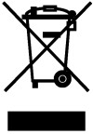

- Descriptions & Specifications:
- This exercise bike with maximum permissible user’s weight is 150 kg and equipped with speed dependent and independent braking system.
- This training equipment is a stationary exercise machine used to simulate biking without causing excessive pressure to the joints, hence decreasing the risk of impact injuries.
- Exercise Bike offer a non-impact cardio vascular workout that can vary from light to high intensity based on the resistance preference set by the user. It will strengthen your muscle of lower limbs and increase cardio capacity and maintain fitness of your body also.
- Before beginning any exercise program, consult your doctor.
- This is especially important for people aged over 35 or who have previously had health problems, and those who have not done any sport for a number of years.

Remark: | - This elliptical trainer is designed for studio use. The variations of power consuming are within ±5W up to 50W and ±10% over 50W.  - For speed dependent operation mode, the braking resistance level can be adjustable manually and the variations of power will depend on the pedaling speed.  - For speed independent operation mode, the user can set the wanted power consumption level in Watt, constant power level will be kept by various braking resistance levels, that will be determined automatically by system. That is independent on the pedaling speed.
Specifications:
Power input: built-in generator& Lead-Acid maintenance free rechargeable battery Dimensions: 1226 mm Lx 648 mm W x 1434 mm H
Weight: 58.5 kg
Minimum space required: 1500 mm Lx 900 mm W x 1700 mm H Maximum training capacity: 300 W at 70 min-1

Warnings and Warranty:

WARNING: | Read all instructions in this manual before use and keep this user’s manual for entire life of this product for further reference.
WARNING: | This equipment is designed for studio use only and home use is not expected.
WARNING: | It is owner’s responsibility to ensure that all users of this elliptical trainer are adequately informed about all safety precautions before use. Use the elliptical trainer only as described in this manual.
WARNING: | Consult your physician before beginning any exercise program.
WARNING: | Do not to use if you feel dizzy or have an acute cold or fever.
WARNING: | Before the training starts, remove all objects within a radius of 2 meters from the machine.
WARNING: | Never insert objects into any openings of this equipment. If an object should drop inside, carefully retrieve it.
WARNING: | Close supervision is necessary when this equipment is being used or near children& disabled persons.
WARNING: | Warning up exercise is necessary before you start your training.
WARNING: | Your health could be impaired by incorrect or excessive trainings. If you feel pain or dizziness while exercising, stop immediately and cool down then consult a doctor before beginning a planned training program.
WARNING: | The function pulse measuring is not categorized as a medical device. Various factors like user’s movement, will affect the reading’s accuracy of the heart rate. The pulse measuring is intended only as an exercise aid in determining heart rate rends in general.
WARNING: | Wear appropriate exercise clothing and when using the trainer. Do not wear loose clothing that could be caught by this trainer.
WARNING: | Assemble the machine exactly as described in the installation instructions and use the enclosed parts only with appropriate hand-tools described inside.
WARNING: | Place this equipment on a stable & even surface and keep it away from moisture and dust. Make sure that there is enough space around this equipment to mount, dismount, and use this equipment.  Note: It is recommended to keep any obstacles, projections away with a distance of 1 m.
WARNING: | Inspect and properly tighten all parts regularly and. If any damages were found, keep this equipment out of use until repair and call our service center or the retailer for further helps.
WARNING: | Always follow the console instructions for proper operations.
WARNING: | When you stop exercising, allow the pedals come to a stop slowly.
WARNING: | Allow only one person at a time on your machine.

Warranty:
The product is guaranteed under normal conditions of use of the structure and wearing parts for 2 years from the date of purchase, as indicated by the date on the receipt. This appliance is for light commercial use. This warranty is limited to the replacement or repair of the product at the direction of your local agent.

This warranty does not apply to cases of ：
  - Damages caused during transport
  - Improper or abnormal use
  - Repairs made by technicians not approved by your local agent.

For any further questions, please contact the local agent or retail

Assembly
Note:
Check all the parts included with shown in the manual. If parts are missed or damaged, do not use it and please return to your local distributor.
Use originals only, safety cannot be ensured if any unapproved components were used.
Make sure the space is free from anything that may cause injury and keep unsupervised children, pets, disable persons& senior citizens during assembly.
If you have any question or doubts during assembling, please contact with customer service center for helps.

PARTS LIST

NO. | DESCRIPTION | QTY | NO. | DESCRIPTION | QTY
1 | BASE FRAME | 1 | 41 | CONTACT HR STAINLESS STEEL | 4
2 | FRONT SHROUD(LEFT) | 1 | 42 | CONTACT HR PLASTIC(SCREW END) | 1
3 | FRONT SHROUD(RIGHT) | 1 | 43 | FILLISTER HEAD SCREW M3*35L(BLACK) | 4
4 | SCREW #10-32*3/4"L(BLACK) | 6 | 44 | CONSOLE | 1
5 | SCREW M5*15L(BLACK) | 8 | 45 | BOTTLE HOLDER | 1
6 | CARNK(R&L) | 1 | 46 | CONSOLE MAST PLUG | 1
7 | PEDAL(R&L) | 1 | 47 | BATTERY | 1
8 | SCREW M8*25L(BLACK) | 2 | 48 | BELT J8 1321 | 1
9 | ALLEN HEAD SCREW M16 | 1 | 49 | BELT TENSIONER ARM | 1
10 | SADDLE SUPPORT TUBE INSERT ABS | 1 | 50 | BELT TENSION SPRING | 1
11 | FRONT STABILIZER | 1 | 51 | BEARING <6203ZZ> | 2
12 | SCREW M5*20L(BLACK) | 2 | 52 | C17 CLIP | 1
13 | SCREW M8*40L | 2 | 53 | WHEEL SOCKET | 3
14 | WASHER M8*Ø16*1.2T | 14 | 54 | SCREW M5*13.2L(BLACK) | 3
15 | WHEEL / BLACK | 2 | 55 | BEARING <6004ZZ> | 2
16 | NYLOCK NUT M8 | 2 | 56 | C20 CLIP | 2
17 | WASHER M8*Ø16*1.2T (BLACK) | 4 | 57 | NYLOCK NUT M8(BLACK) | 4
18 | SPRING WASHER M8(BLACK) | 4 | 58 | BIG BELT PULLEY(Ø310) | 1
19 | ALLEN HEAD SCREW M8*20L(BLACK) | 4 | 59 | MAGNET | 1
20 | ADJUST LEVER KNOB | 4 | 60 | AXLE FOR PULLEY | 1
21 | ALLEN HEAD SCREW M8*90L | 4 | 61 | SCREW M8*18L | 4
22 | REAR STABILIZER | 1 | 62 | CONTROL BOARD | 1
23 | STABILIZER END CAP | 4 | 63 | SPEED SENSOR WIRE 600L | 1
24 | BOOM | 1 | 64 | SPEED SENSOR BRACKET | 1
25 | SADDLE POST | 1 | 65 | SCREW M6*12L(BLACK) | 1
26 | SEAT BOTTOM | 1 | 66 | CONTROL BOARD CABLE 800L | 1
27 | WASHER OD16 x ID08 x 1.2MM | 3 | 67 | BRAKE CABLE | 1
28 | NYLOCK NUT M8 | 3 | 68 | HEX SCREW M6*20L(BLACK) | 4
29 | SCREW M8*25L | 6 | 69 | SPRING WASHER M6 | 4
30 | MIDDLE SPEED SENSOR WIRE | 1 | 70 | WASHER M6*16*1.5T(BLACK) | 4
31 | HANDLEBAR HR WIRE 700L | 2 | 71 | BRAKE (CHI HWA-GENERATOR) | 1
32 | UPPER SPEED SENSOR WIRE | 1 | 72 | DOUBLE-SIDE FORM TAPE | 1
33 | SPRING WASHER M8 | 10 | 73 | CAP | 1
34 | CONSLOE HANDLE BAR MAST | 1 | 74 | SCREW M4*10L(BLACK) | 4
35 | HANDLEBAR(LEFT) | 1 | 76 | SCREW M4*8L | 6
36 | HANDLEBAR(RIGHT) | 1 | 77 | SCREW M5*15L(BLACK) | 4
37 | BOTTLE | 1 | 78 | POWER CABLE | 1
38 | SCREW M5*10L(BLACK) | 2 | 80 | SCREW M4*10L | 4
39 | CONTACT HR END CAP | 2 | 81 | CONSOLE BRACKET | 1
40 | HEX NUT M3(BLACK) | 4 | 82 | SCREW M4*12L(BLACK) | 4

Exploded View 1
MANY OF THE PRATS SHOWN HERE HAVE BEEN PRE-ASSEMBLED AT THE FACTORY.

Exploded View 2
ALL THE PRATS SHOWN HERE HAVE BEEN PRE-ASSEMBLED AT THE FACTORY.
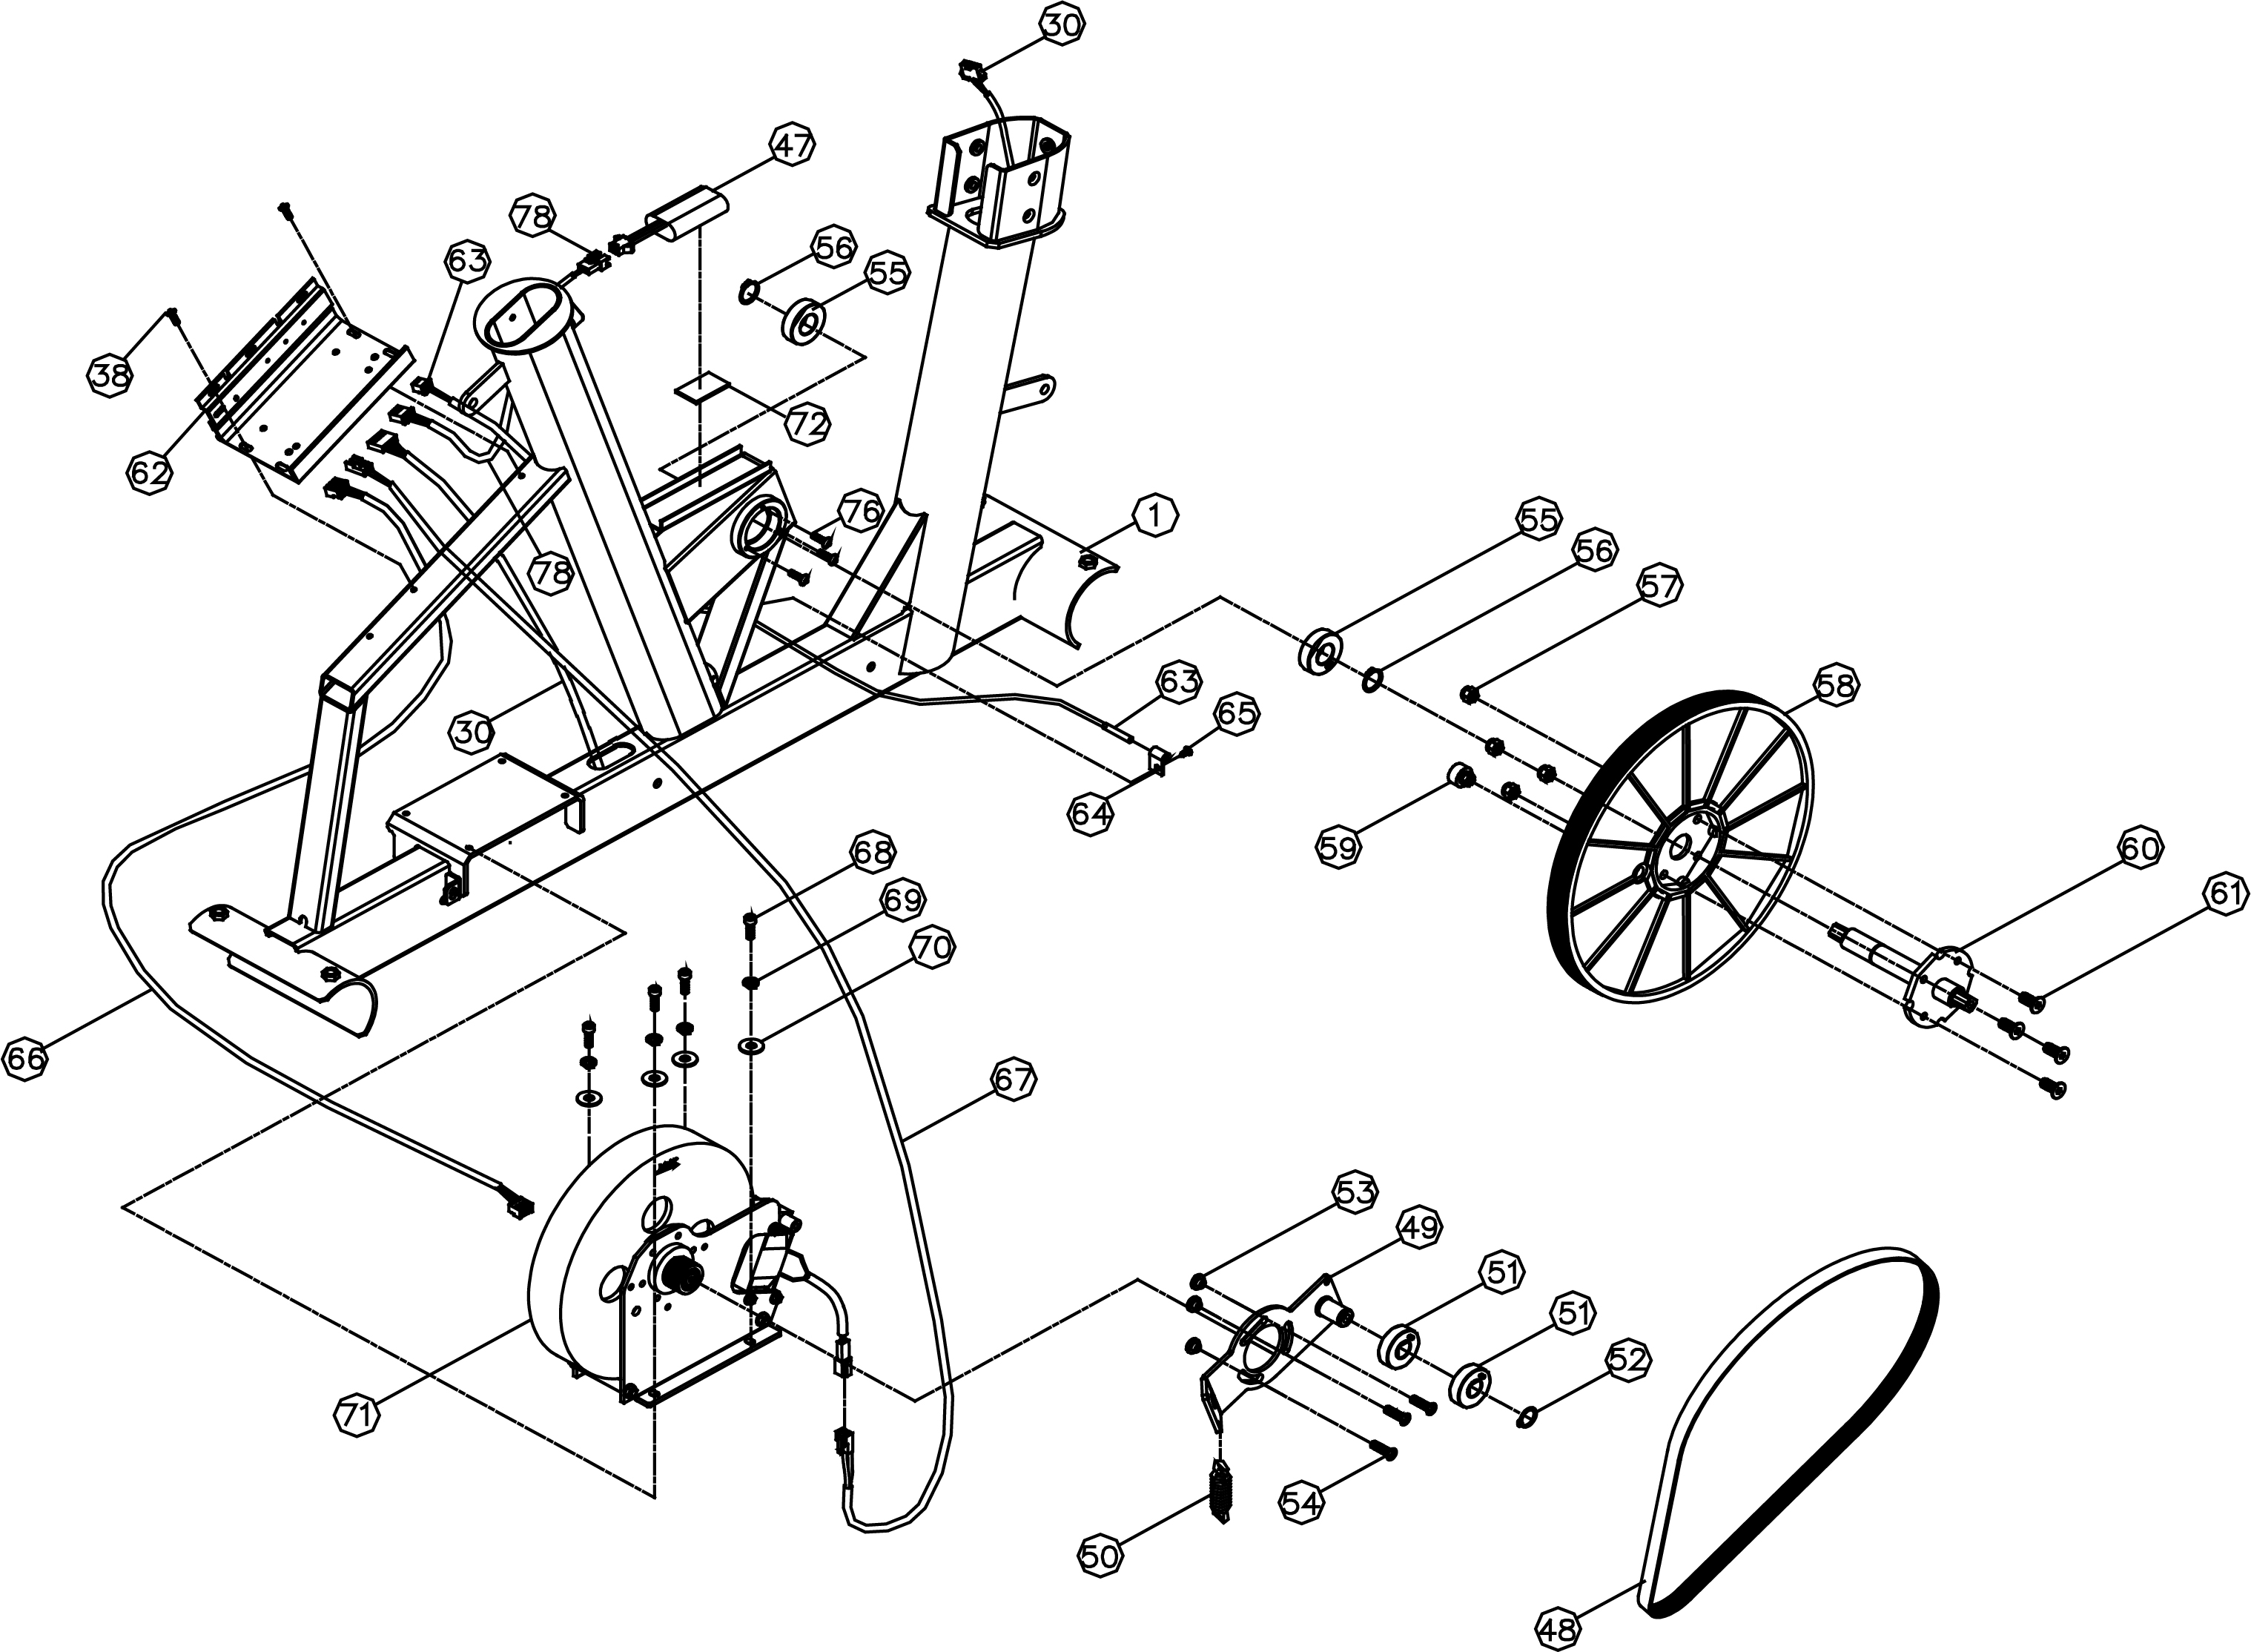
Hardware chart

14 17
Item | Hardware | Q’ty
5 | SCREW M5*15L/ BK | 2
14 | WASHER M8*Ø16*1.2T | 10
17 | WASHER M8*Ø16*1.2T / BK | 4
18 | SPRING WASHER M8 / BK | 4
19 | ALLEN HEAD SCREW M8*20L /BK | 4
21 | ALLEN HEAD SCREW M8*90L | 4
29 | SCREW M8*20L | 6
33 | M8 SPRING WAHER | 10
TOOL | PHILLIPS HEAD TIP SCREWDRIVER | 1
 | SPANNER | 1

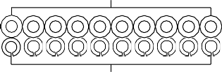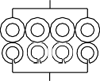

33
21 29
18
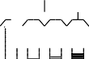
19 5

Assembly & Installation Instructions

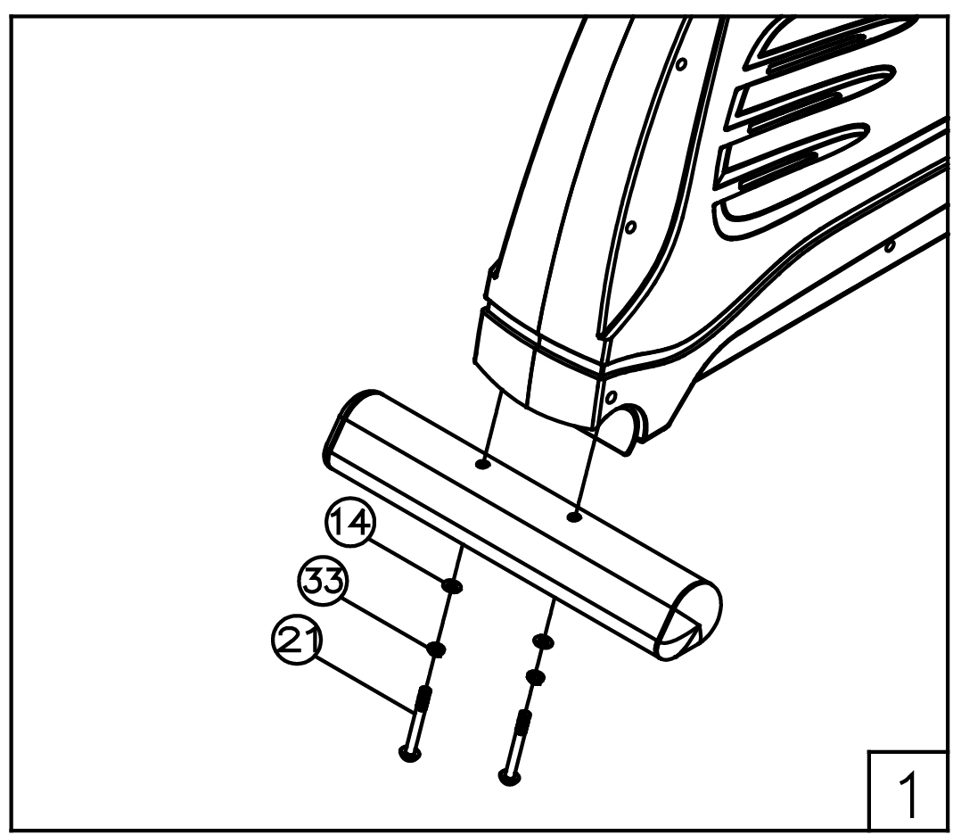
STEP 1 - Attach Rear Stabilizer
Fasten Rear Stabilizer (22) to the Base (1) using: 2 – M8 Washers (14)
2 – M8 Spring Washers (33)
2 – M8 Allen Head Screws (21)

Note: It will help to place a piece of the polystyrene packaging under the bike when assembling the front stabilizer.
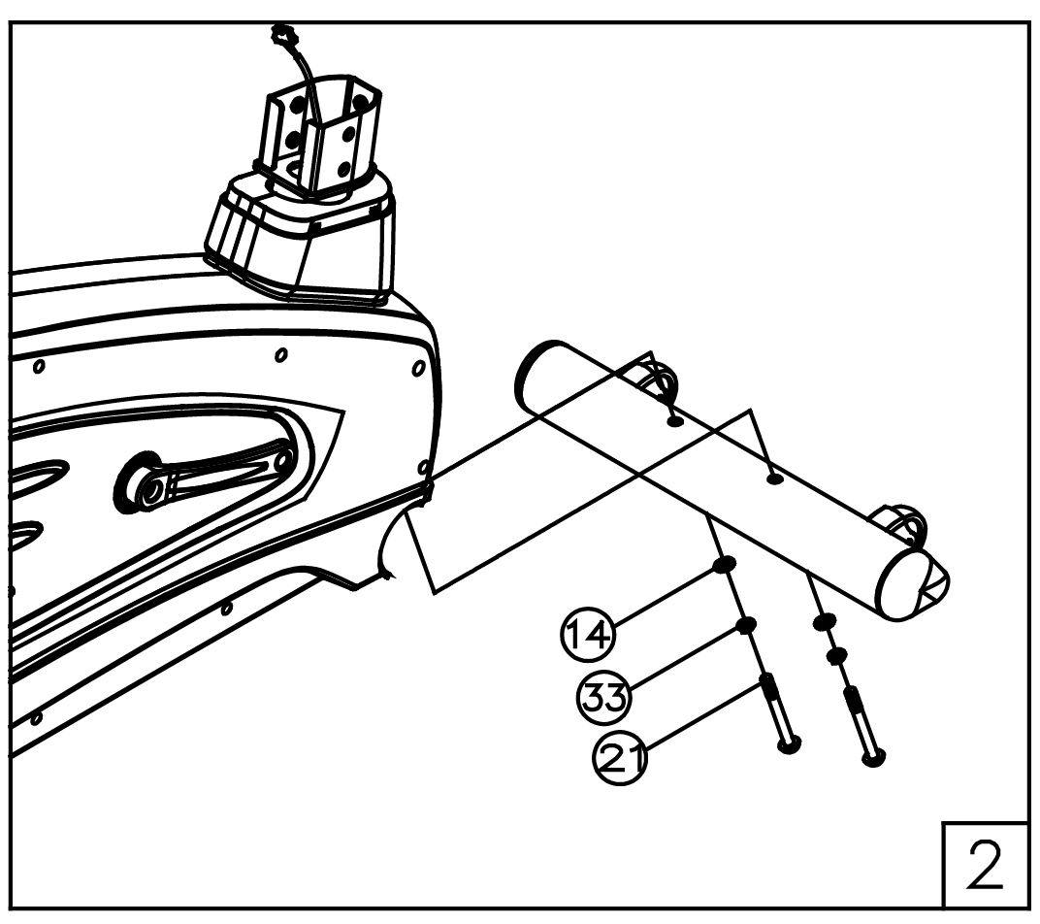
STEP 2 - Attach Front Stabilizer
Fasten Front Stabilizer (11) to the Base (1) using: 2 – M8 Washers (14)
2 – M8 Spring Washers (33)
2 – M8 Allen Head Screws (21)

Note: It will help to place a piece of the polystyrene packaging under the bike when assembling the front stabilizer.
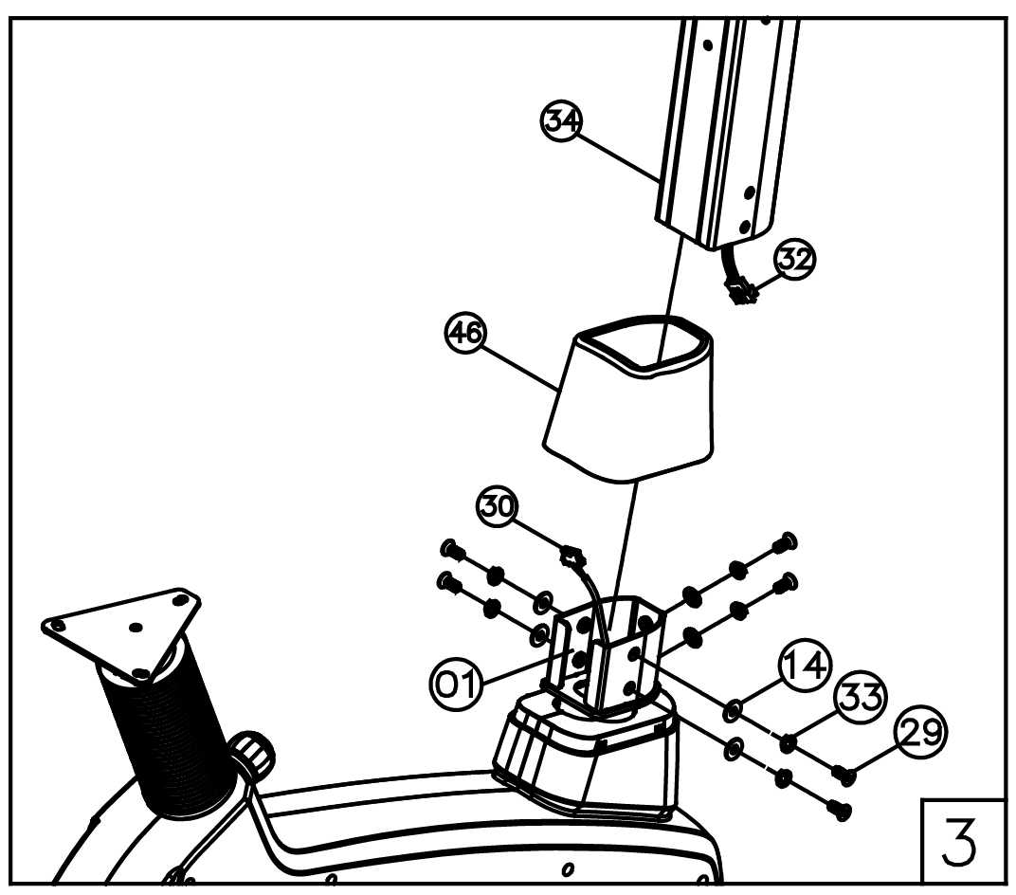
STEP 3 - Attach the Console Handlebar Mast
Insert the Console Handle Bar Mast (34) through the plastic cover (46) and into the base and attach it using: 4– M8 Washers (14)
4– M8 Spring Washers (33)
4– M8 Allen Head Screws (29)

STEP 4 –Attach the Water Bottle Holder
Attach the Bottle Cage (45) to the Console Handlebar Mast using :

2 – M5 x 10MM Screws (05)
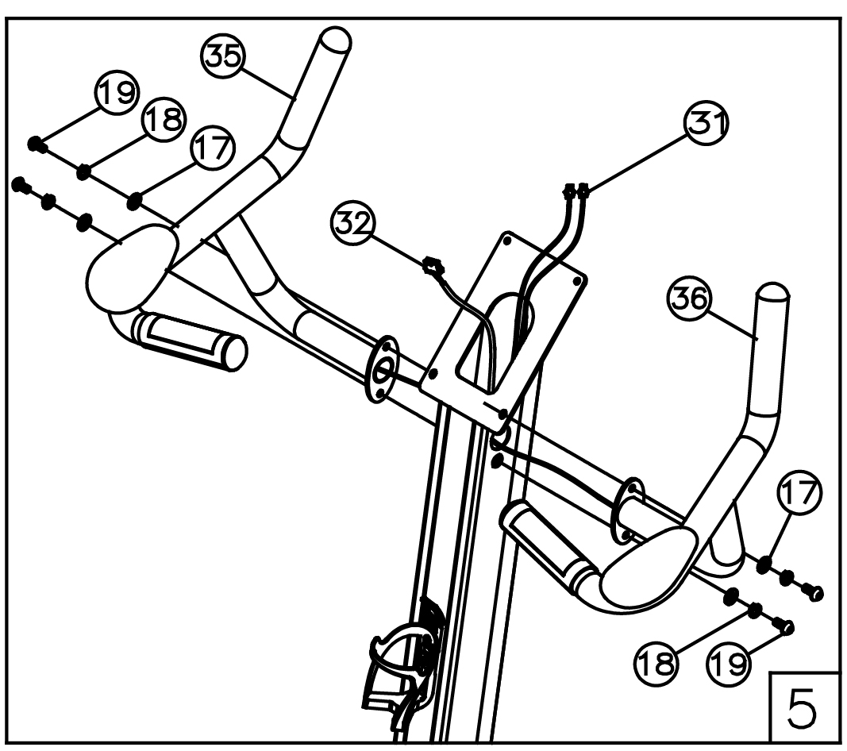
Step 5 – Install Handlebar
Attach the Handlebar Left (35) and the Handlebar Right (36) to the Handlebar Mast
(34) using:

4– M8 Washers (17)
4– M8 Spring Washers (18)
4– M8 Allen Head Screws (19)

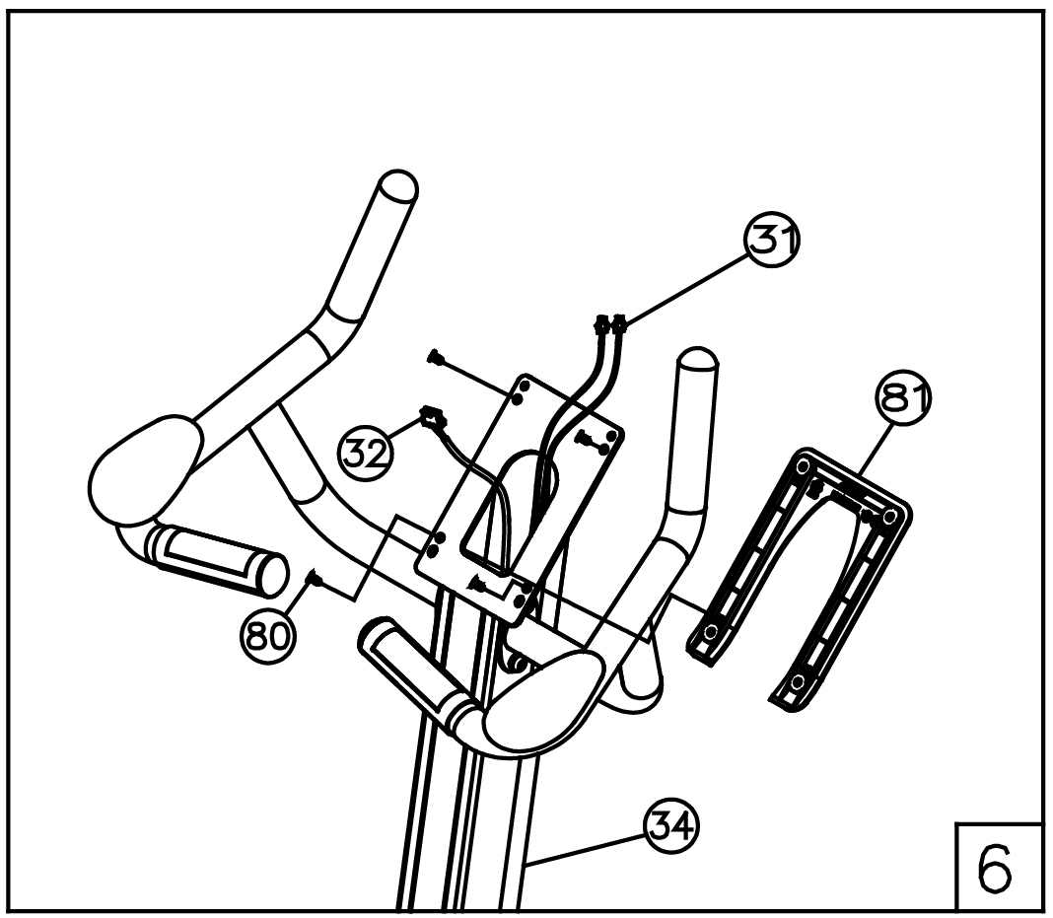
Step 6 – Install console handle bar cover.
Attach cover (81) on Console Handle Bar(34). Using 4- M4*10L screw (80)
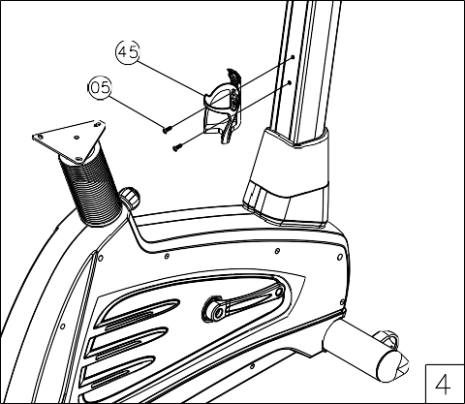

Step 7 – Install Console  Insert the Handlebar HR Wire (31) and Upper Speed Sensor Wire (32) into the 3 wires that on the back side of the Console (44).  Attach the Console (44) to the Handle bar Mast (34) using:  4– M5 x 10MM Screw (77) | 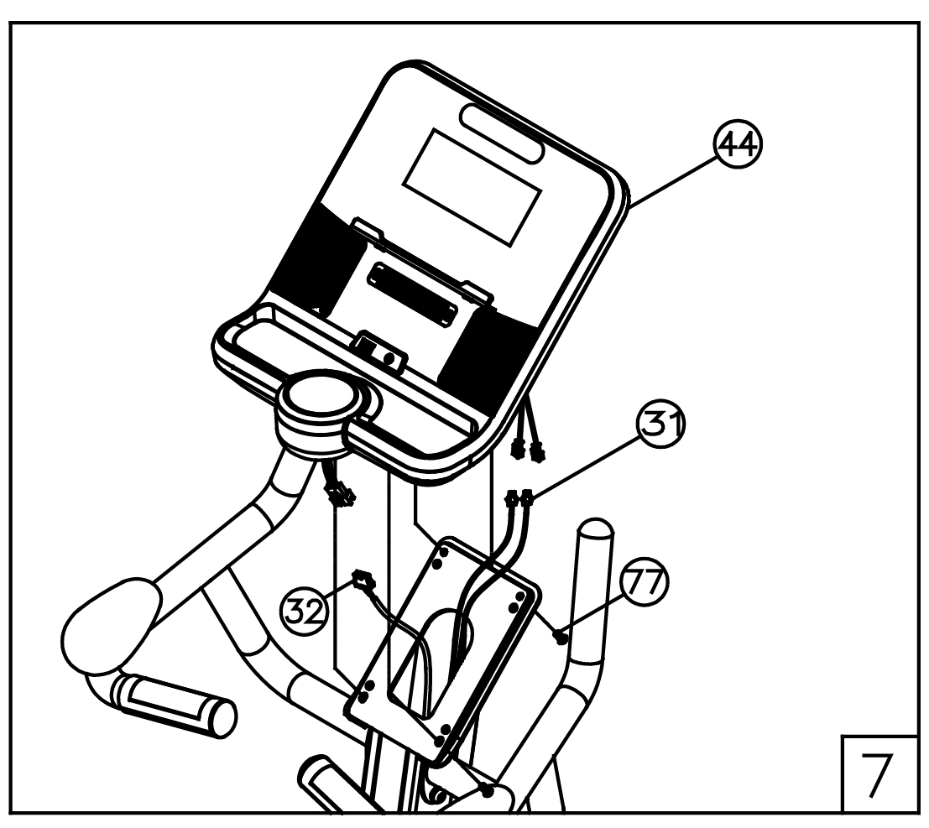
Step 8 – Install Saddle  Attach the Saddle (26) to the Saddle Post (25) using: 3– M16 Washers (27)  3– M8 Nylock Nuts (28) | 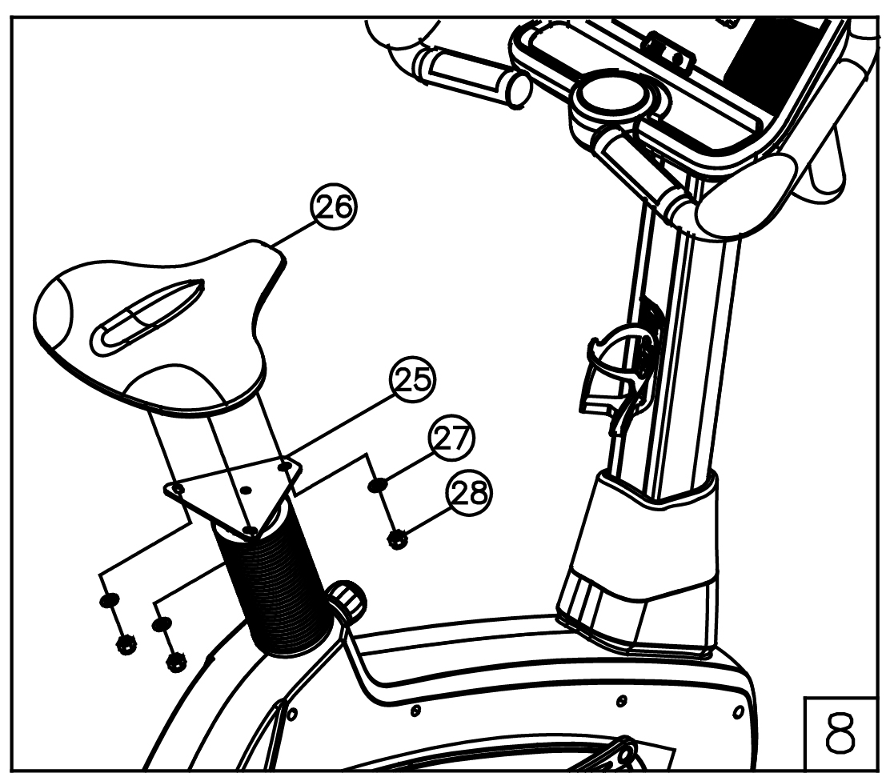
Step 9 – Install Pedal  Insert the Right Pedal (07) into the right arm of the Crank assembly (06) and finger tighten in a clockwise direction until the thread is fully inserted in the crank.  Repeat for the Left Pedal (07) finger tighten in an anticlockwise direction. Tighten both with the spanner. | 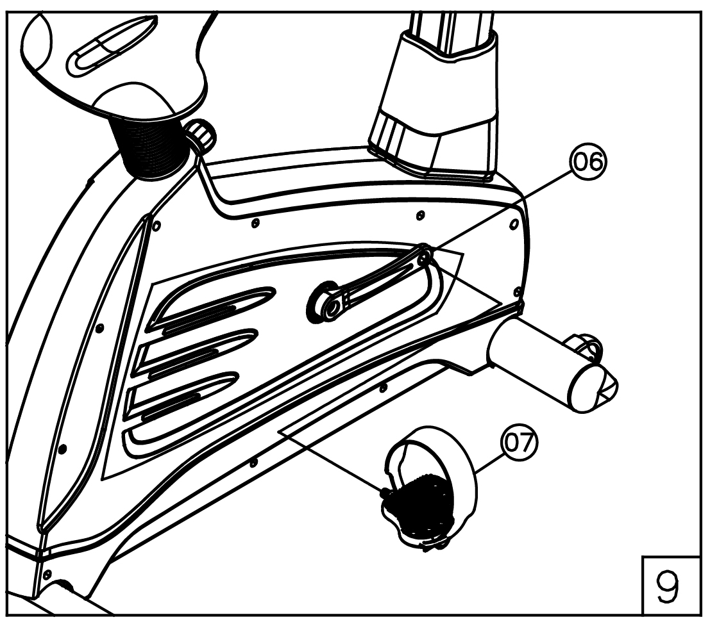
Step 10 – FINAL INSPECTION
Your new upright Bike is now assembled. Prior to use, check all parts for proper installation and ensure that all hardware is completely secured.

Instructions of Use
Exercise Advices – Warm-up
Warming up is a preparatory phase before any activity. It puts the person into optimum conditions for carrying out his or her favorite sport, and it is also a method to prevent accidents to tendons and muscles. For general warming up, it must be sufficiently long: 15 min for a leisure sport activity, 25 min for a competition sport activity, but also varies from person to person. Find the most comfortable positioning of the user self on the machine, adjust the seat position (see below) and select a fairly weak pedaling resistance and exercise at your own rhythm.
WARNING: | Consult your physician before beginning any exercise program.
WARNING: | Do not to use if you feel dizzy or have an acute cold or fever.
WARNING: | Your health could be impaired by incorrect or excessive trainings. If you feel pain or dizziness while exercising, stop immediately and cool down then consult a doctor before beginning a planned training program.

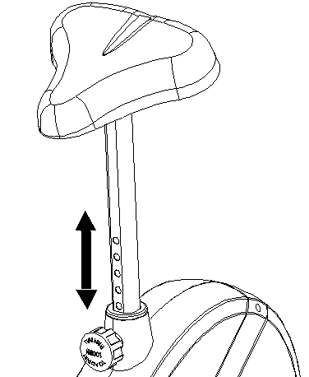
Adjustment – Seat Position
For an effective workout, the seat must be adjusted properly. While your are pedaling, your Knees should be slightly bent when the pedals are in the farthest position. In order to adjust the seat, unscrew the knob few turns and draw it out slightly. Adjust the seat to the right height, then release the knob and tighten it all the way.

Important:
Make sure to put the knob back into place in the seat post and tighten it completely. Never exceed the maximum height of the seat.
Always get off the bicycle before making any adjustment.

Mount, Use & Dismount
Mount:
  - After the seat is adjusted to properly position, insert your foot into retaining strap of pedal step on the pedal and hold the handlebar tightly.
  - Try to put whole body weight on your foot and simultaneously cross over the trainer and land your another foot on the other side.
  - Now you are in the position to start your training.

Use:
- Keep you hands on the handlebar, and both feet are insert into retaining straps of both pedal properly.
- Pedal your exercise bike by your both feet alternately.
- Then you can increase the pedaling speed gradually and adjust braking resistance levels to increase the exercise intension.

Dismount:
- Slow down the pedaling speed until it comes to rest.
- Keep the left hand grabbing the left handlebar tightly, put your feet cross over the equipment and land on the floor, then land the other one.

Maintenance

WARNING: | Replace the worm parts immediately and keep this equipment out of use until repaired.
WARNING: | Safety of the equipment can be maintained only if the equipment is inspected regularly for damage or wear.
Please follow the procedures to maintain your equipment：
  - Locate your training equipment in ventilated, dry& cool place
  - Inspect and tighten all parts regularly (daily survey and check conducted by technician every half year are recommended).
  - Clean the stepping surface of the pedals regularly.
  - Wipe the console, handgrips of handlebar with damped clothes and mild detergent. Do not use any chemical solvent even perfume on this equipment.

NOTE：The transmission elements are guarded by the ABS enclosure to prevent form unintentional access, maintenance for those elements are not necessary, but if unusual noise emitted during normal use, it means the driving belts were worn or bearings were damaged, please contact the retailer for further service.

Adjustment – Resistance
Braking and resistance are connected to pedaling speed. A modern electronic generator
DOWN

system enables you to adjust the braking resistance using or console (the resistance level is indicated on the screen.)
UP

Training Indication – Load Table

Training Indication – Load Table
functions of the

Test Titile：RPM and Wattage from Level 1 to Level 36 |  |  |  |  |  |  |  | Model：A1100G |  |  |  | Type： Generator |  |  |  | Year: 2015
WATTAGE |  | Level | Level | Level | Level | Level | Level | Level | Level | Level | Level | Level | Level | Level | Level | Level | Level
RPM |  | 1 | 2 | 3 | 4 | 5 | 6 | 7 | 8 | 9 | 10 | 11 | 12 | 13 | 14 | 15 | 16
40  RPM | Console Ave. Value | 10 | 15 | 20 | 22 | 25 | 30 | 36 | 40 | 45 | 50 | 56 | 62 | 68 | 73 | 76 | 81
50  RPM | Console Ave. Value | 15 | 20 | 26 | 33 | 38 | 44 | 52 | 57 | 64 | 68 | 76 | 80 | 85 | 89 | 92 | 97
60  RPM | Console Ave. Value | 17 | 25 | 34 | 42 | 50 | 58 | 66 | 74 | 82 | 90 | 98 | 104 | 110 | 116 | 122 | 128
70  RPM | Console Ave. Value | 21 | 25 | 34 | 42 | 50 | 58 | 66 | 74 | 82 | 90 | 98 | 104 | 110 | 147 | 153 | 162
WATTAGE |  | Level | Level | Level | Level | Level | Level | Level | Level | Level | Level | Level | Level | Level | Level | Level | Level
RPM |  | 17 | 18 | 19 | 20 | 21 | 22 | 23 | 24 | 25 | 26 | 27 | 28 | 29 | 30 | 31 | 32
40  RPM | Console Ave. Value | 85 | 91 | 96 | 103 | 107 | 111 | 118 | 126 | 133 | 166 | 165 | 164 | 167 | 166 | 167 | 168
50  RPM | Console Ave. Value | 103 | 107 | 112 | 117 | 122 | 125 | 131 | 137 | 139 | 147 | 152 | 158 | 165 | 172 | 175 | 183
60  RPM | Console Ave. Value | 134 | 140 | 146 | 152 | 158 | 164 | 170 | 176 | 182 | 188 | 194 | 200 | 206 | 213 | 219 | 225
70  RPM | Console Ave. Value | 169 | 176 | 182 | 187 | 196 | 201 | 209 | 215 | 220 | 226 | 235 | 242 | 250 | 256 | 262 | 267

Test Titile：RPM and Wattage from Level 1 to Level 36 |  |  |  |  |  |  |  | Model：A1100G |  |  |  | Type： Generator |  |  |  | Year: 2015
WATTAGE |  | Level | Level | Level | Level | Level | Level | Level | Level | Level | Level | Level | Level | Level | Level | Level | Level
RPM |  | 33 | 34 | 35 | 36
40  RPM | Console Ave. Value | 170 | 173 | 172 | 176
50  RPM | Console Ave. Value | 190 | 198 | 205 | 220
60  RPM | Console Ave. Value | 231 | 237 | 244 | 250
70  RPM | Console Ave. Value | 277 | 283 | 291 | 300

Remarks：1. The power consumptions (Watt) are calibrated by measuring the driving speed (min-1) of axle and the braking torque (Nm).
- For compliance with Class A, the tolerance for power:
  - up to 50W shall be within ± 5W
  - over 50W shall be within ±10%

Operation Manual of Console

Overview of Console

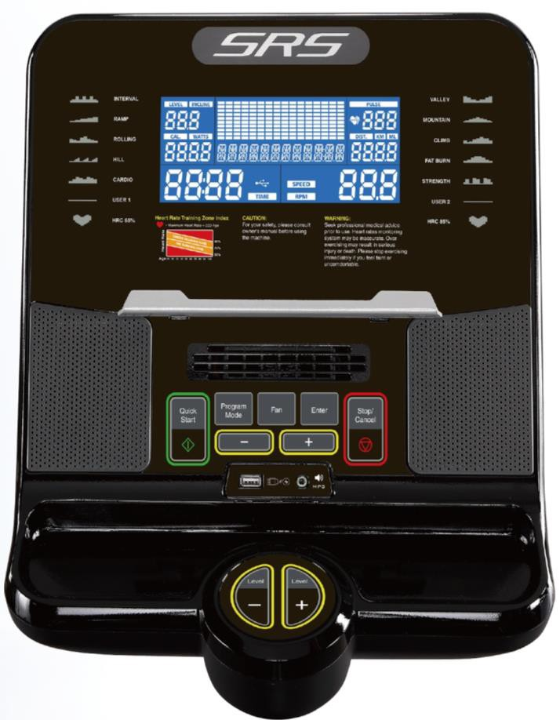
LCD Display Screen
Tablet
Program Mode
Quick Start
Fan
Enter
Down ( – )
Stop /
Cancel UP (＋ )
Audio and
USB Ports

Console Introduction：
This console is LCD displayed with blue backlight, the display sections include LEVEL/INCLINE 、PULSE(HEART RATE)、CALORIES、WATTS、DIST./KML、TIME、RPM、SPEED and the center
information window indicates PROGRAM selection , Resistance profile and User Data you are using .

This Console offer 1 Manual Program, 10 profile programs, 2 User programs and 2 Heart Rate Programs to keep you motivated and on track to achieving your fitness goals.

- Status Of Console：
A． Power On Status：Pedal the machine, after supplying enough power the amplifier will beep and then LCD will start the beginning status in 2 seconds. (See Photo1), Next the display window appear total value of time and distance and “ VER 1.0” in 3 seconds (see Photo 2) and then go into User Data setting .( See Photo 3)
B． IDLE Mode Status：After no signals input for 5 minutes, or hold the Stop/Cancel key for 3 seconds when in
a program, the console will automatically go into IDLE Mode Status, the display window will appear each Program profile and then shows “ SELECT PROFRAM OR QUICK START”. (See Photo 4)
C． Auto Shut-Off (Sleep Mode ) ：In power on status , the console will automatically shut off in 90 seconds
without using and any signals input. Pedal the machine can wake up the console.

- When meets the following situations, the value of TIME, DISTANCE, CALORIES, PULSE can be reset.
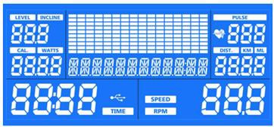
When power inserts and goes into the Beginning Status, LCD starts in 2 seconds. (See Photo 1)
= Photo 1 =
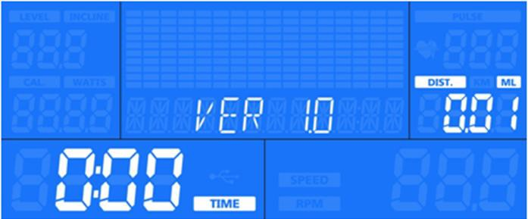
= Photo 2 =
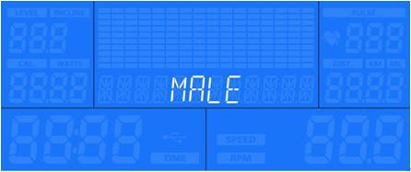
= Photo 3 =

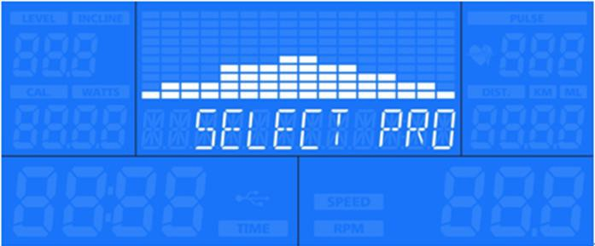
= Photo 4 =

- Display Function

Item | Function | Display Range | Set Up | Simple Instruction
1 | TIME | 00：00 - 99：59  Flash 0.5 seconds per time | 0-99:59  (one cycle) | - When set at 0：00, the value  adds up  - When set at 01：00-99：00，the  goal time value will count backwards until 0, Beeps to stop.
2 | SPEED | 0.0-99.9 KPH/MPH  Flash 0.5 seconds per time | 0-99.9 KPH/MPH | - Displays the estimated speed of exercise (Miles or KM per hour)  - The counting values base on Mile and then change to KM
3 | RPM | 0-999 | No | When exercise, WATTS/CAL RPM/SPEED values display in turns every 6 seconds.
4 | DISTANCE | 0.00-99.99 KM  Flash 0.5 seconds per time | 0.0-99.99  (One Cycle) | - When set at 0：00, the value  adds up  - When set at 0.1-99.99， the goal  distance value will count backwards until 0, Beeps to stop.  - The counting values base on Mile and then change to KM
5 | PULSE | 40-200 BPM  Flash 0.5 seconds per time | 0-40-200  BPM | - Pulse value goes beyond the Upper limit value.  - No pulse input, the pulse window will show “ P ”
6 | LEVEL/INC LINE | 1-36 LEVEL  Flash 0.5 seconds per time | 1-36 LEVEL | - Display the resistance level of exercise.  - Min level is 1 and Max is 36
7 | CALORIES | 0-9999 CAL  Flash 0.5 seconds per time | 0-10-9990  (One Cycle) | - When set at 0, the value adds up  - When set at 0-10-9990， the  goal calories value will count backwards until 0, Beeps to stop.
8 | WATTS | 0-9999 | No. | Display the current power you are producing at a given resistance level.(Ref Watts table)

- Key Function

- Quick Start | Used to start the workout program. When the center window display program name such like MANUAL, pressing this key will start the manual program.
- Stop/ Cancel | Used to pause or stop workout. When in a program, pressing this key to pause workout. When pause in 90 seconds, pressing this key again can restart the clock and the program where you left off. Hold this key for 3 seconds to stop workout and back to IDLE Mode.
- Enter Key | Confirms or enters your selection
● UP (＋) / DOWN (–) | Used to change resistance level or to select workout programs or to adjust values such as program time etc.
- Program Mode | When in IDEL Mode, pressing this key to enter the workout program profile.

- Fan | Press this key to turn on and off the FAN function. Normally the Fan is off, press one time to turn on and next continue pressing two times to turn off. ( OFF →1→2→OFF )
- Console Operation
  - User Data Setting：After power up and enter User Data setting , you can set-up the personal data.
    - The center LCD window display “MALE” , using “ UP (＋) /Down( –)“ key to select MALE or FEMALE and confirm with “ Enter” key .
    - The center LCD window display “AGE 35”, when number flash , using UP (＋)/Down( –)“ key to adjust age value and
confirm with Enter key.

    - The center LCD window display “ HIGHT 180 “, when number flash , using UP(＋)/Down( –)“ key to adjust high value and confirm with Enter key .
    - The center LCD window display “ WEIGHT 70” , When number flash , using UP(＋)/Down( –)“ key to adjust weight value
and confirm with Enter key to go into IDLE MODE.

  - Quick Start：When in IDEL Mode, press Quick Start key to take you immediately to the Manual Program. Resistance level will be Level 1. Time will start from 00:00 and count up. Using UP(＋)/Down( –)“ key to adjust resistance level at any time or
press “Stop / Cancel “key to pause your workout .

  - Manual program : When in IDEL Mode, press Program Mode key to enter program. Using UP(＋)/Down( –) key to scroll through display until you reach “ MANUAL”, then press Enter key to confirm selection. In the Manual program, pressing Enter key can select either of TIME, DIST. or CAL as your workout target, during exercise ,the setting value display will count down form the number you entered to 0. You can press “ Quick Start “key without any setting to begin workout and all value display will count up from 0.
  - Time Goal：Press Enter key to select “ TIME”, the Time default value “20:00” will be flashing, you can set your desired
workout time by using UP(＋)/Down( –) key, then press Quick Start key to begin exercise.
  - Distance Goal：Press Enter key to select “Distance”, the “DIST. default value” 14.0” KM/ML will be flashing, you can set your desired workout distance by using UP(＋)/Down( –) key, then press Quick Start key to begin exercise.
  - Calorie Goal：Press Enter key to select “Calories”, the “CAL“ default value “ 50 “CAL , you can select the calorie goal you wish to burn by using UP(＋)/Down( –) key, then press Quick Start key to begin exercise.
  - Enter Level : During exercise , you can adjust resistance level (1-36) with using UP(＋)/Down( –) key at any time.
  - Switch Display window : During exercise, you can switch display window to review the workout data with Enter key.
  - To Stop or Pause the program : Press Stop / Cancel key to pause program or hold this key in 3 seconds to stop program.

  - Select Profile Programs : When in IDEL Mode , press Program Mode key to enter program. There are 10 program levels can be selected (see photo table). The program profile and name will appear in the center of LCD display, using UP (＋)
/Down( –) key to scroll through display until you reach “ Programs”, then press Enter key to confirm and goes into setting workout Time .You can press Quick Start key with default value to begin exercise or press Stop / Cancel key back to IDEL Mode for re-selection.

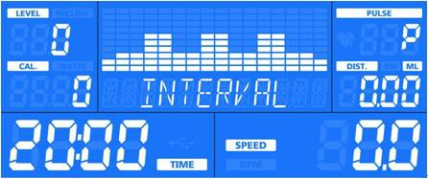 | 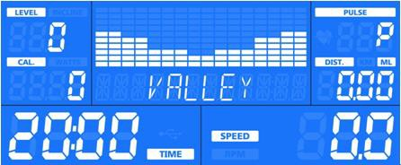

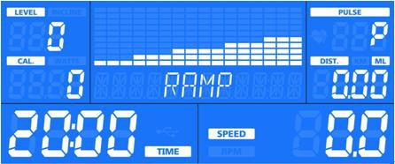

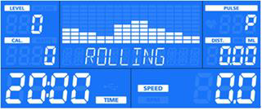
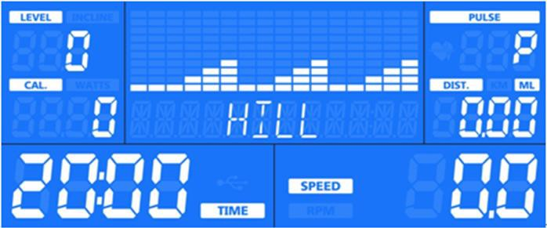

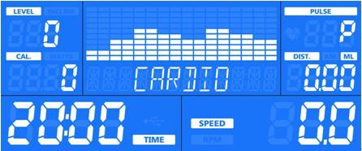
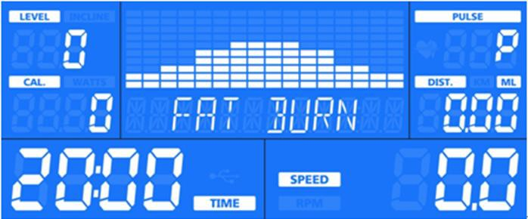
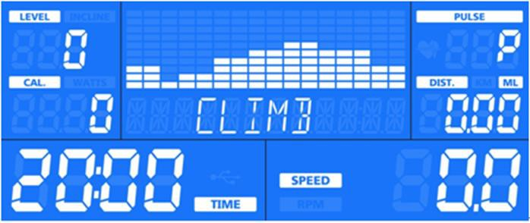
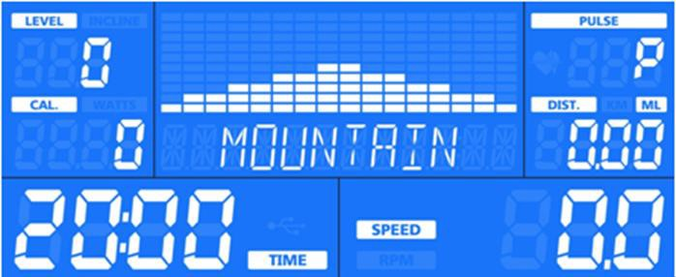

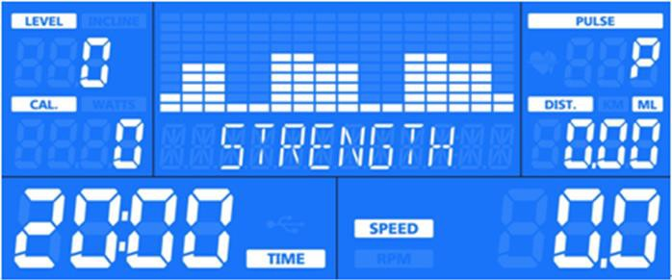
  - Select User Program : When in IDEL Mode , press Program Mode key to enter program. Using UP(＋)/ Down( –) key to select USER 1 or USER 2 Program , then press Enter key to confirm the selection and then go into setting your personal data and create your own workout profile. You can press Quick Start key with default value to begin exercise or press
Stop / Cancel key back to IDEL Mode for re-selection.
  - Setting personal Data : Press Enter key to go data setting, using UP(＋)/ Down( –) key to select your sex and adjust your Age, Weight, Height and workout time. Pressing Enter key after each data point once you have entered desired value.
  - Creating workout Profile : Press Enter key to select Level , the Level value and program profile (The first column indicated in the center of LCD window ) will be flashing, adjust UP (＋)/Down (–) key to set resistance levels and press Enter key to move to next column, there are 16 columns, if desired, continue until all columns are programmed, then
press Quick Start key to begin your own workout program.
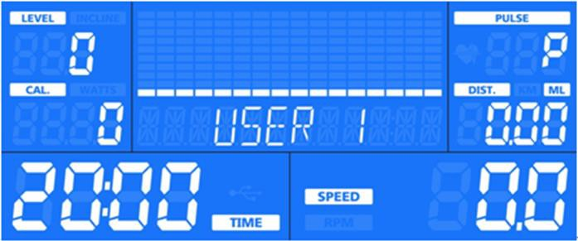
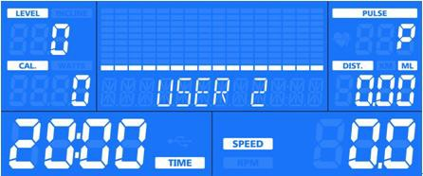

  - Select HRC Program: When in IDEL Mode, press Program Mode key to enter program. Using UP (＋)/Down(–) key
to select HRC 1 or HRC 2 Program, press Enter key to confirm the selection and then go into setting your personal data and create your own workout profile. You can press Quick Start key with default value to begin exercise or press Stop / Cancel key back to IDEL Mode for re-selection.
  - Time Goal : Press Enter key to select “ TIME”, the time default value “20:00” will be flashing, using UP(＋)/Down (–)
key to set up your desired workout time and confirm with Enter key to go next setting or press Quick Start key to begin exercise.
  - Setting Target hart rate (THR) : Press Enter key to set THR value, the LCD window will appear “ THR 120/157 “ and flashing value. To increase and decrease value with Using UP (＋)/Down(–) key and confirm with Enter key or press
Quick Start key to begin exercise.
  - Setting Resistance Level : Using UP (＋)/Down(–) key to adjust the resistance level at any time.
  - Wireless chest band ( Heart Rate Transmitter ) : Using wireless chest band to start HRT program ,the center window will appear ” CHECK PULSE” and then hart icon “♥ “ will be flashing after getting user pulse , if no pulse input in 15 seconds , the console will automatically stop workout program.

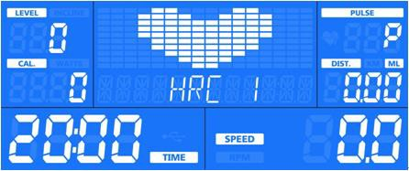  HRC 65% | 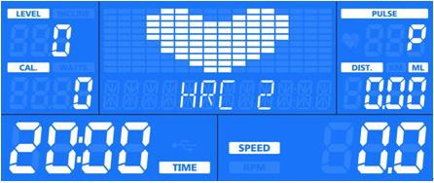  HRC85%

Other
When hands place on the hand pulse sensor, the sparkling ♥ signal can be seen in the PULSE section, value shows from 50 to 210 BPM. If it shows P, it fails to sense the heartbeat.

Training Instructions
You must consider the following factors in determining the amount of training effort required in order to attain tangible physical and health benefits:

Intensity
The level of physical exertion in training must exceed the level of normal exertion without reaching the point of breathlessness and / or exhaustion. A suitable guideline for effective training can be taken from the pulse rate. During training this should rise to the region of between 65% to 85% of the maximum pulse rate (see the table and formula for determination and calculation of this).

During the first weeks, the pulse rate should remain at the lower end of this region, at around 65% of the maximum pulse rate. In the course of the following weeks and months, the pulse rate should be slowly raised to the upper limit of 85% of the maximum pulse rate. The better the physical condition of the person doing the exercise, the more the level of training should be increased to remain in the region of between 65% to 85% of the maximum pulse rate. This should be done by lengthening the time for the training and / or increasing the level of difficulty.

If the pulse rate is not shown on the computer display or if fir safety reasons you wish to check your pulse rate, which could have been displayed wrongly due to error in use, etc., you can do the following:
    - Pulse rate measurement in the conventional way (feeling the pulse at the wrist, for example, and counting the

numbers of beats in one minutes).
    - Pulse rate measurement with a suitable specialized device (available from dealers specializing in health-related equipment).

Frequency
Most experts recommend a combination of health-conscious nutrition, which must be determined on the basis of your training goal, and physical training three times a week. A normal adult must train two times a week to maintain his current level of condition. At least three training sessions a week are required to improve one’s condition and reduce one’s weight. Of course the ideal frequency of training is five sessions a week.

Planning the training
Each training sessions should consist of three phases: the warm-up phase, the training phase, and the cold-down phase. The body temperature and oxygen intake should rise slowly in the warm-up phase. This can be done with gymnastic exercises lasting five to ten minutes.

Then the actual training (training phase) should begin. The training exertion should be relatively low for the first few minutes and then raise over a period of 15 to 30 minutes such the pulse rate regions of between 65% to 85% of the maximum pulse rate.

In order to support the circulation after the training phase and to prevent aching or strained muscles later, it’s necessary to follow the training phase with a cool-down phase. This should be consisted of stretching exercises and / or light gymnastic exercise for a period of five to ten minutes.

Motivation
The key to a successful program is regular training. You should set a fixed time and place for each day of training and prepare yourself mentally for the training. Only train when you are in the mood for it and always have your goal in view. With continuous training you will be able to see how you are progressing day by day and are approaching your personal training goal bit by bit.

Body workout
Training on this machine is to increase your cardio-vascular capacity, based on this principle; you can improve your physical condition, endurance and calories burning. Finally, the exercise bike allows you to tone the muscles in the legs and buttocks.

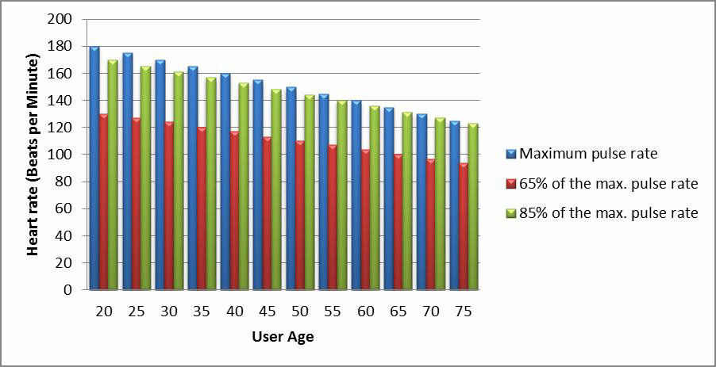

Calculation formula:
Maximum pulse rate = | 220-Age
85% of the max. pulse rate = | (220-Age)×0.85
65% of the max. pulse rate = | (220-Age)×0.65

Troubleshooting

- If the heart rate indicator is not flashing or is flashing erratically, check that your hands are positioned properly and that the sensors are not to moist
- If the counter does not turn on, check the condition and the connection of the cables on the back of the console, and where the stem meets the main frame of the bike
- If the problem persists, contact our customer service or bring the product back to your dealer

＊＊＊＊＊＊ Enjoy your new Upright Bike！ ＊＊＊＊＊＊

